NAME – SUMAN GHOSH
ROLL NO- UG/SOET/30/24/570
LAB Assignment (Studio 3T)
COLLECTION 1: flights
Schema
{
flight_id: Number,
airline: String,
source: String,
destination: String,
price: Number,
duration: Number
}
COLLECTION 2: bookings
Schema
{
booking_id: Number,
passenger_name: String,
flight_id: Number,
city: String,
seats: Number,
total_fare: Number
}
MongoDB query INSERTION
use airlineDB

db.createCollection("flights")
db.createCollection("bookings")

db.flights.insertMany([
{ flight_id: 1, airline: "Indigo", source: "Delhi", destination: "Mumbai", price: 5000, duration: 2 },
{ flight_id: 2, airline: "AirIndia", source: "Kolkata", destination: "Chennai", price: 6500, duration: 3 },
{ flight_id: 3, airline: "SpiceJet", source: "Mumbai", destination: "Bangalore", price: 4000, duration: 1.5 },
{ flight_id: 4, airline: "Vistara", source: "Delhi", destination: "Chennai", price: 7000, duration: 3 },
{ flight_id: 5, airline: "GoFirst", source: "Mumbai", destination: "Delhi", price: 4800, duration: 2 },
{ flight_id: 6, airline: "Indigo", source: "Bangalore", destination: "Kolkata", price: 5500, duration: 2.5 }])

db.bookings.insertMany([
{ booking_id: 101, passenger_name: "Aarav", flight_id: 1, city: "Delhi", seats: 1, total_fare: 5000 },
{ booking_id: 102, passenger_name: "Meera", flight_id: 2, city: "Kolkata", seats: 2, total_fare: 13000 },
{ booking_id: 103, passenger_name: "Rohan", flight_id: 3, city: "Mumbai", seats: 1, total_fare: 4000 },
{ booking_id: 104, passenger_name: "Sneha", flight_id: 4, city: "Delhi", seats: 3, total_fare: 21000 },
{ booking_id: 105, passenger_name: "Kunal", flight_id: 5, city: "Mumbai", seats: 2, total_fare: 9600 },
{ booking_id: 106, passenger_name: "Priya", flight_id: 6, city: "Bangalore", seats: 1, total_fare: 5500 }
])
db.bookings.find()
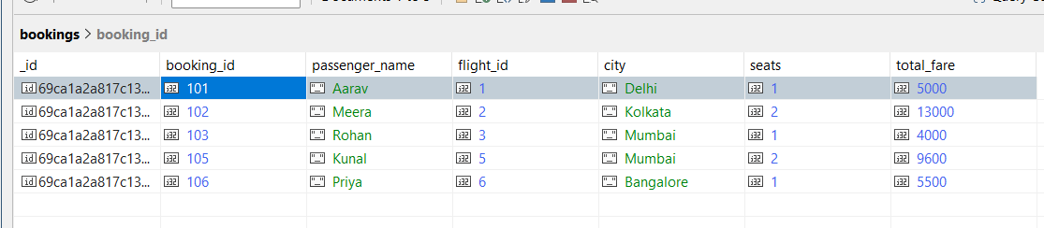
QUESTIONS
Q1. Display all flights.
db.flights.find()
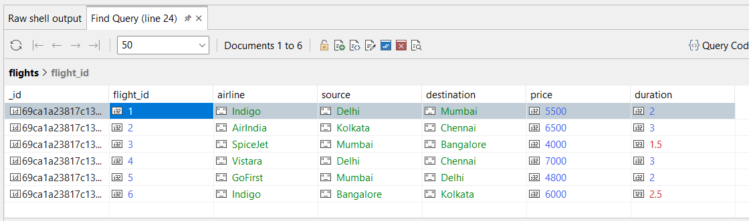

Q2. Display passenger_name and city from bookings.
db.bookings.find({}, { passenger_name: 1, city: 1, _id: 0 })
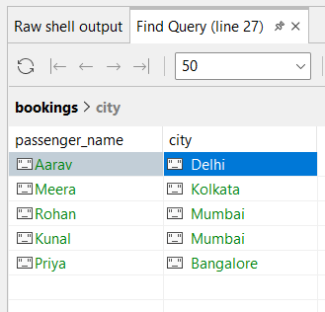
Q3. Find flights where source is Delhi.
db.flights.find({ source: "Delhi" })
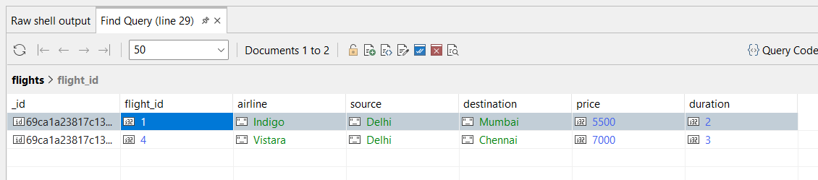

Q4. Find bookings where seats = 1.
db.bookings.find({ seats: 1 })
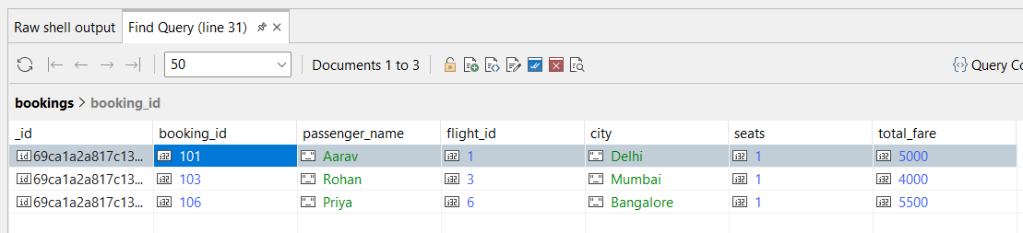
Q5. Sort flights by price in ascending order.
db.flights.find().sort({ price: 1 })
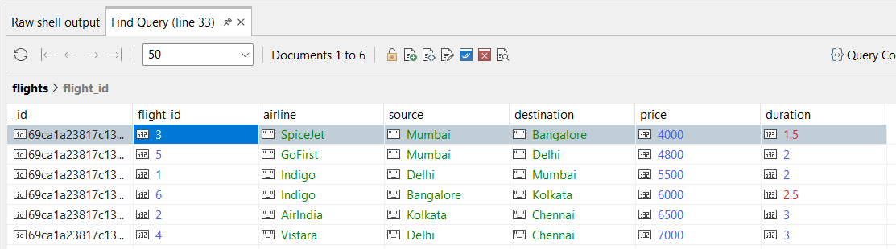
Q6. Display top 2 bookings with highest total_fare.
db.bookings.find().sort({ total_fare: -1 }).limit(2)
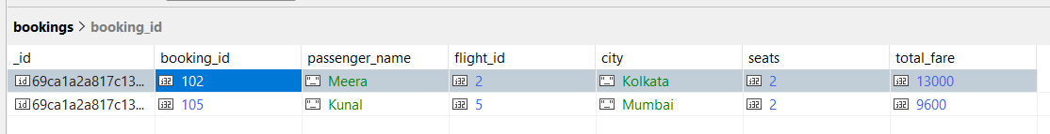
Q7. Find flights where price is greater than 5000.
db.flights.find({ price: { $gt: 5000 } })
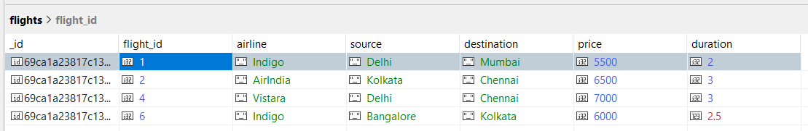

Q8. Display flights where destination is not Chennai.
db.flights.find({ destination: { $ne: "Chennai" } })
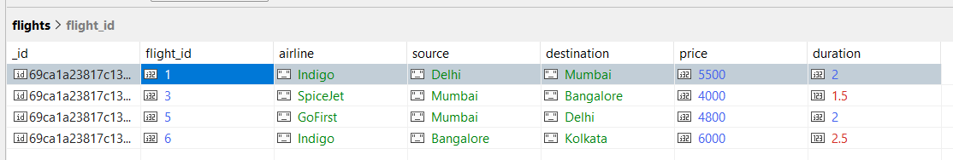
Q9. Find bookings where seats are between 1 and 2.
db.bookings.find({ seats: { $gte: 1, $lte: 2 } })
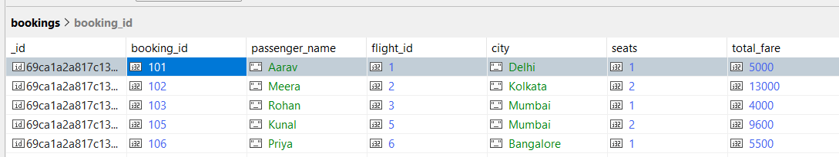
Q10. Update price by +500 for flights of airline "Indigo".
db.flights.updateMany(
{ airline: "Indigo" },
{ $inc: { price: 500 } }
)
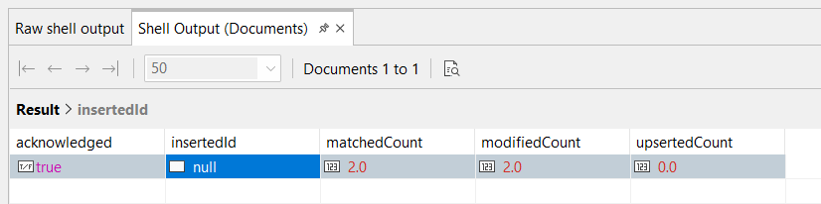
Q11. Delete bookings where seats are greater than 2.
db.bookings.deleteMany({ seats: { $gt: 2 } })
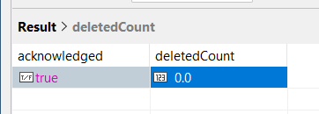

Q12. Find total fare collected city-wise. (Aggregation)
db.bookings.aggregate([{ $group: { _id: "$city", total_fare_collected: { $sum: "$total_fare" } } }])
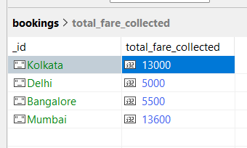
Q13. Find average flight price per airline. (Aggregation)
db.flights.aggregate([{ $group: { _id: "$airline", Avg_flight_price: { $avg: "$price" } } }])
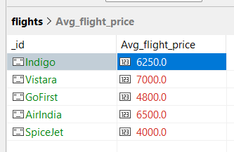

Q14. Display airlines where average price is greater than 5500. (Aggregation + filter)
db.flights.aggregate([{ $group: { _id: "$airline", avg_price: { $avg: "$price" } } }, { $match: { avg_price: { $gt: 5500 } } }])
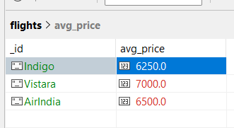

Q15. Find maximum total_fare among bookings for each city. (Aggregation)
db.bookings.aggregate([{ $group: { _id: "$city", max_total_fare: { $max: "$total_fare" } } }])
